Just for fun  The first five terms for each nth term on the left can be found in the number jumble. Can you find them all?  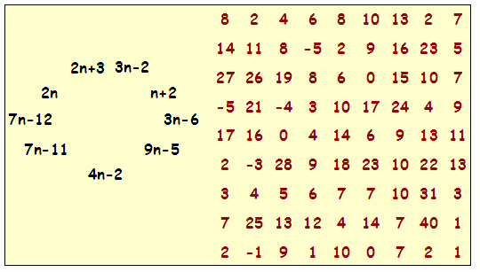  Revise at home  Further support and practice is available on mymaths.co.uk  School login:____________________ Password____________________  *Booster packs  *Six boosters  *Sequences  *Sequences revision (level 6) (lesson & online Worksheet)  *Library  *Algebra  *Sequences  * nth term (level 6) (lesson & homework task)  * Quadratic sequences (level 7) (lesson & homework task) |  | Name:  Finding the nth term of a sequence  Sequences level ladder  Level Objective G A R  7a I can find the n^{th} term of quadratic sequences  7c I can find the next term of quadratic sequences  6a I can write an expression to describe the nth term of an arithmetic sequence.  6c I can generate terms of a sequence using term-to-term and position-to-term definitions of the sequence.  Key vocabulary  Sequence Term Generate Arithmetic Quadratic Difference  Matching activity  Use this table to record your answers.  Sequence n^{th} term Comments
More Level 6  1 Find the next three terms in each of these sequences:  a 1, 5, 9, 13, ____, ____, ____, ……….  b 2, 9, 16, 23, ____, ____, ____, ………  2 Write down the first four terms of the following sequences:  a 4n + 5  b 2n – 3  3 Find the n^{th} term of each of the following sequences:  a 8, 15, 22, 29, 36, …………  b 43, 51, 59, 67, 75, ………..  c 21, 19, 17, 15, 13,………….  d -11, -9, -7, -5, -3,……….. |  | Into Level 7  1 Find the next three terms in each of these sequences:  a 6, 12, 20, 30, ____, ____, ____, ……….  b 2, 5, 10, 17, ____, ____, ____, ………  2 Write down the first four terms of the following sequences:  a n² +5  b n (n +3)  3 Find the n^{th} term of each of the following sequences:  a 1, 4, 9, 16, 25, ……………..  b 3, 6, 11, 18, 27, ……………..  c 2, 8, 18, 32, 50…………….  d ½, 2, 4 ½, 8, 12 ½, ………….

